Weather and Climate ….. Chapter 1 Vocab. – SECTION 2
- radiation – the transfer of energy as electromagnetic waves
(Earth only receives two-billionths of this energy.)
- thermal conduction – the transfer of energy as heat through a material
(Is always transferred from war to cold areas ………..
warm surface of Earth atmosphere)
- convection – the transfer of thermal energy by the circulation or movement of a liquid
or gas (Most thermal energy in atmosphere is transferred by _________.)
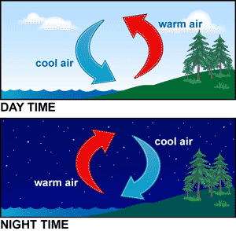
- convection current – the cycle of warm air rising and cool air sinking

- Greenhouse Effect – process where atmospheric gases absorb thermal energy and
radiate it back to Earth.
(atmosphere like a blanket OR glass walls/roof of greenhouse
trapping solar energy preventing it from escaping)
- radiation balance – balance between incoming energy and outgoing energy
- global warming – a gradual increase in average global temperature
(human activity like burning fossil fuels & deforestation may increase
levels of greenhouse gases that absorb thermal energy)

