Ch 1 Sect. 4 – AIR POLLUTION (Lecture and TEAM notes)

- Air Pollution – contaminated air from human and natural pollutants
- After thousands died in London from 4 days of thick polluted fog in 1952, England started making air-pollution laws. Many nations are doing the same now.

Primary Pollutants
NATURAL sources of pollutants that are put directly in the air: | HUMAN sources of pollutants that are put directly in the air:
- Dust  - Sea salt  - Volcanic gases & ash  - Forest fire smoke  - Pollen | - CO (carbon monoxide) – car exhaust  - Dust  - Smoke  - Chemicals from paint (& other things)

Secondary Pollutants (& The Formation of Smog)
Two examples of secondary pollutants that form when primary pollutants REACT with other primary pollutants OR with naturally occurring substances include:
- OZONE = produced when car exhaust & air reacts with sunlight
(Ozone is good in the stratosphere, but damages lungs when near Earth’s surface.)
- SMOG = forms when ozone & car exhaust reacts with sunlight
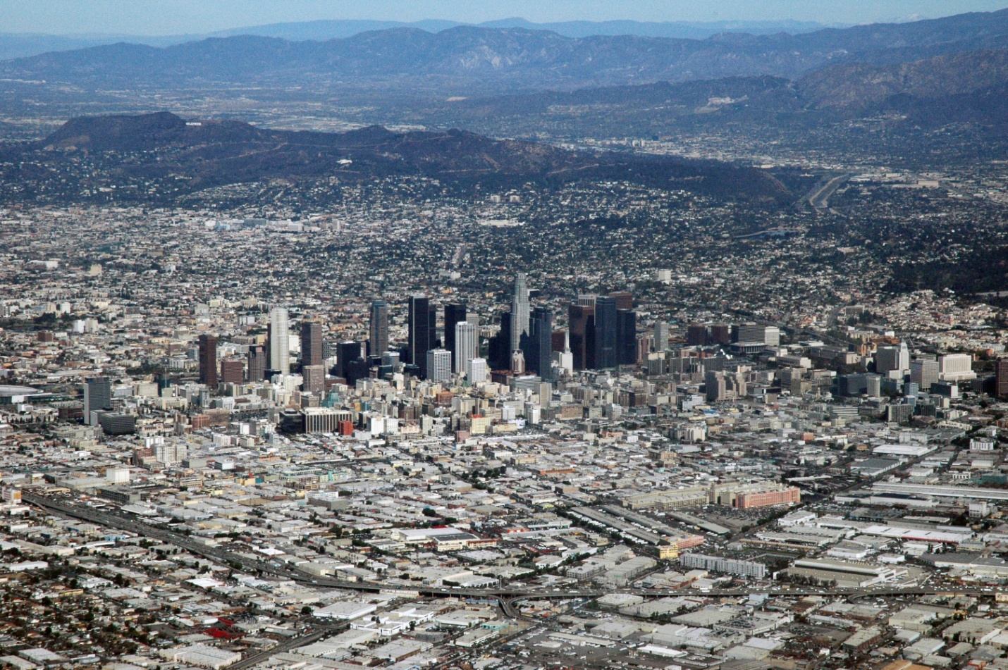
Los Angeles, California is almost completely surrounded by mountains, which trap pollutants that contribute to their serious smog problem.
Sources of Human-Caused Air Pollution
- Automobile exhaust contains nitrogen oxide, which contributes to smog & acid rain
  - Transportation contributes 10 – 20% of human-caused air pollution
  - Pollution controls & cleaner fuel has reduced air pollution from vehicles
Industrial Air Pollution
Many industries put out A LOT of pollutants in the air:
- Electric Power Plants (burn coal)
- Chemical Manufacturing
- Oil Refineries
- Dry-Cleaning Businesses
- Furniture Refinishers
- Auto Body Shops

Indoor Air Pollution
- Sometimes air inside a building can be more polluted than the air outside.
- Some sources of indoor air pollution:
  - Fungi / Bacteria (dirty ductwork)
  - Nitrogen Oxide (unvented gas stove / wood stove / kerosene heater)
  - Chlorine / Ammonia (cleaning products)
  - Chemicals (dry-cleaning)
  - Carbon Monoxide (CO) (faulty furnace / run car in attached garage)
  - Solvents (paint strippers / thinners)
  - Gasoline (for car or mowers)
  - Formaldehyde (furniture / carpet / particleboard / foam insulation)
- 2 ways to reduce indoor air pollution:
  - Ventilation = mixing outdoor and indoor air
  - Reduce the use of chemical solvents and cleaners

Acid Precipitation
- Any form of precipitation that contains acids from air pollution.
- Burning fossil fuels release sulfur dioxide and nitrogen oxide in air.
- When they combine with water vapor, they form sulfuric acid & nitric acid
Acid Precipitation and Plants
- Acidification = increase of soil’s acidity due to acid precipitation

  - Problems with higher soil acidity:
- Plants don’t get the increased dissolved and washed-away nutrients
- Aluminum and other toxic metals are released & absorbed by plant roots
The Effects of Acid Precipitation on Forests
- Three areas with the most damage to forests:
Geographic distribution of acid rain
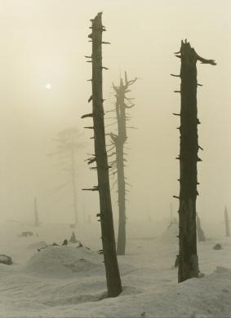
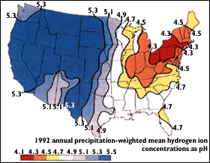
Acidity in rain is measured by collecting samples of rain and measuring its pH. To find the distribution of rain acidity, weather conditions are monitored and rain samples are collected at sites all over the country. The areas of greatest acidity (lowest pH values) are located in the Northeastern United States. This pattern of high acidity is caused by the large number of cities, the dense population, and the concentration of power and industrial plants in the Northeast. In addition, the prevailing wind direction brings storms and pollution to the Northeast from the Midwest, and dust from the soil and rocks in the Northeastern United States is less likely to neutralize acidity in the rain. (http://ga.water.usgs.gov/edu/acidrain.html)
EASTERN EUROPE - Dead and damaged trees, the effects of acid-rain. Precipitation can contain both dilute sulphuric and nitric acids, formed as the result of the absorption of sulphur dioxide and nitrogen dioxides in the atmosphere. (http://www.hardrainproject.com/hrpl?n=563)
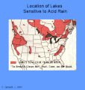
It is now clear that acid rain has already caused wide-spread acidification of lakes and forests in the Northeastern U.S., Eastern Canada, Norway, Sweden, and the United Kingdom (Britain). In Norway and Sweden fish have died in 6500 lakes and 7 Atlantic Salmon rivers. (http://www.lycos.com/info/acid-rain--fish.html)

Acid Precipitation and Aquatic Ecosystems
- Acidity changes in a lake/stream harm aquatic plants & organisms as well as fish
- Worse in spring when acidic snow melt flows in water system
  - Acid Shock – rapid change in body of water’s acid level
  - Spreading lime in spring neutralizes some of the water’s acid
FINISH THE BULLETED SUMMARY LIST FOR THE LAST FEW SECTIONS
The Ozone Hole

Cooperation to Reduce the Ozone Hole

Air Pollution and Human Health

Cleaning up Air Pollution

Controlling Air Pollution from Industry

The Allowance Trading System

Reducing Air Pollution from Vehicles

