ACADEMIC LUNCH SUPPORT

In an effort to increase the number of students who experience success in school, our staff at Surline Middle School has developed and implemented an academic lunch support program. This program can be utilized in two different ways. However, its purpose remains the same as it is used to support all students who need additional help with their academics.

The support program takes place during lunch periods in designated rooms per grade level. An academic support supervisor is available to assist children in completing assignments and to help with general organizational skills. One way this program can be utilized is on a voluntary basis. Any student who wishes to attend the program can check in with the grade-level academic support supervisor before getting their lunch, bring their food back to the room, and eat while completing their work.

Another form of this program is where teachers issue an Academic Lunch Support Referral to students who have not completed an assignment by its due date. This is designed for a child who has not mastered his/her time management when it comes to schoolwork and needs the extra help to develop this skill. The referral form (see back) is designed to monitor a student if he/she is having difficulty completing multiple assignments in a specific class. Records are kept for each individual marking period. One of the main goals of the academic support referral is to keep the parents advised of missing work so additional assistance can be given at home. For this reason, it is MANDATORY that the student is responsible for obtaining a parent signature and returning the referral form to the teacher the day after it was issued. There is a preprinted warning on the form stating that if this teacher directive is not followed, a 45-minute detention will be given. This consequence is designed to help students learn that it is his/her responsibility to take care of this part in the school-home communication.

A common parent (and student) misconception about this program is that a referral or mandatory lunch support session is a punishment. It is NOT designed to be. This is totally separate from a disciplinary referral where a child may receive a detention for improper behavior (see student planner/handbook, pages 29-44). As a staff, our main goal is to help EVERY student be successful with their academics and in developing their overall life skills. We sincerely appreciate the continued partnership we receive from parents in making this possible. If you have any questions or suggestions about how we can improve this positive support program, please feel free to contact the school.

When assignments are given, students are verbally told its due date. This would be the previous action for a written warning.

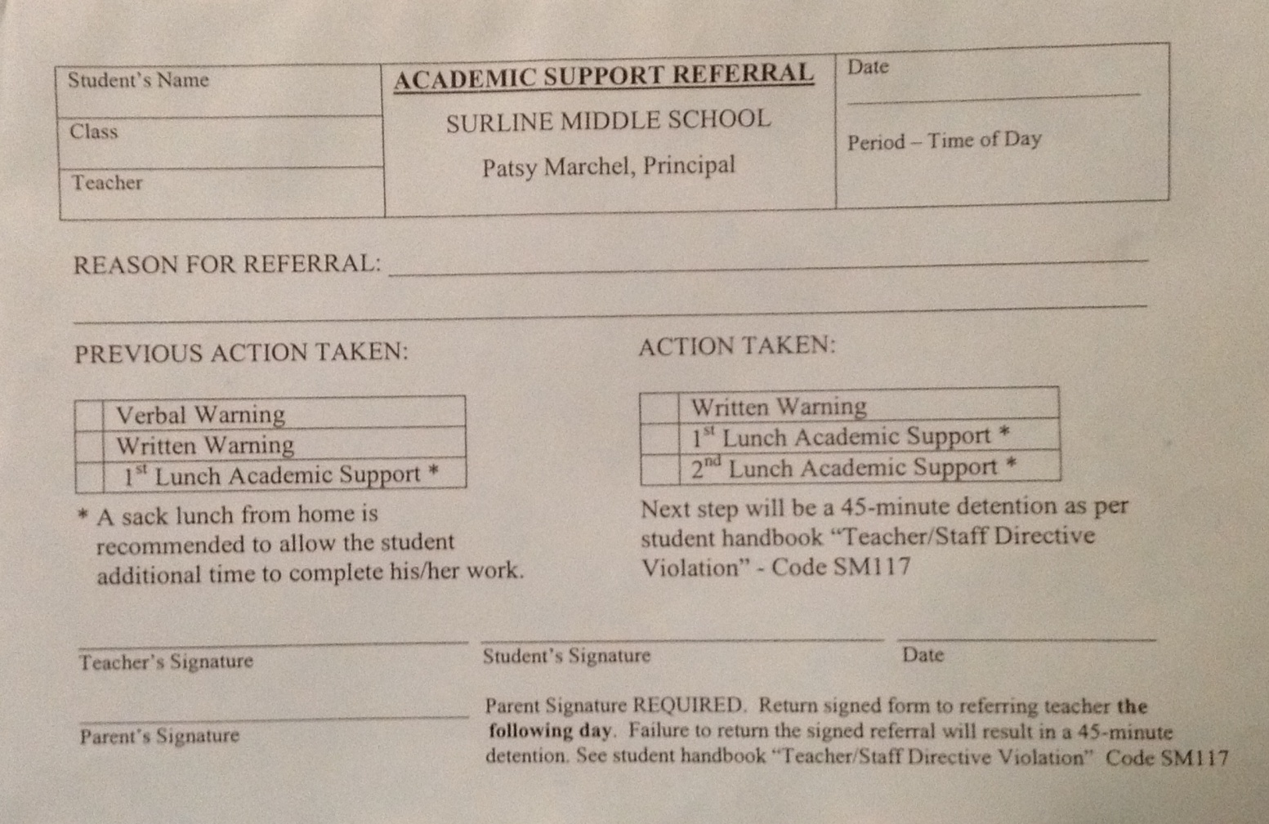
If a habit of not completing work develops (more than 3 per marking period - per teacher), a behavior (discipline) detention will result.
This is the preprinted warning stating that students must bring back the form with a parent signature the day after it was issued or a 45-minute detention will be issued.

